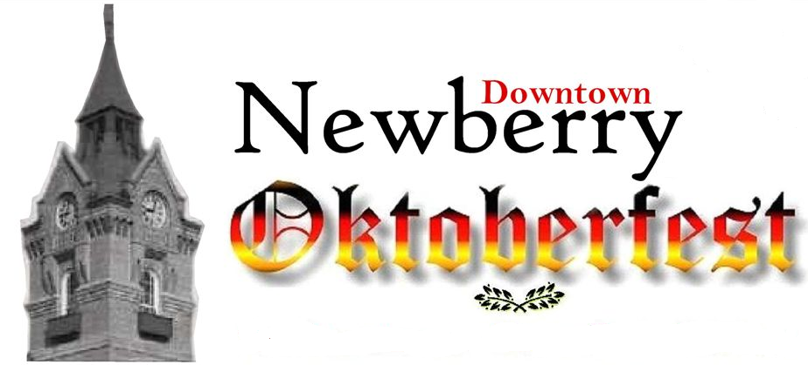  October 1, 2005  10:00am-7:00pm  Entertainment Schedule  Main Stage  (In front of Memorial Park)  Culinary Stage  (In front of Community Hall)  Local Stage  (Main St. near the Ritz Theater)  ALL Entertainment is Free  Schedule Subject To Change  Other Activities:  Food Court Crafts/Vendors Free Kids Rides  Free Petting Zoo(10a-3p) Classic Car display  Sponsored by:  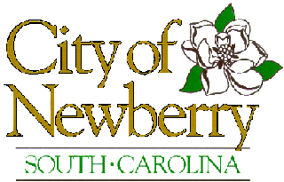    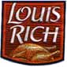  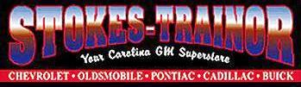   |  | October 1, 2005  10:00am-7:00pm  Entertainment Schedule  Main Stage  (In front of Memorial Park)  Culinary Stage  (In front of Community Hall)  Local Stage  (Main St. near the Ritz Theater)  ALL Entertainment is Free  Schedule Subject To Change  Other Activities:  Food Court Crafts/Vendors Free Kids Rides  Free Petting Zoo(10a-3p) Classic Car display  Sponsored by:
  10:00am- | 3 Dot Polka Band
  1:00pm- | The Caribbean Cowboys
  3:00pm- | DJ Spanky Jim Miller & Free Shag Lessons
  4:00pm- | The Showmen
  11:45am- | Liver Nips Cookoff
  12:00pm- | Brandon Draeger (Delamater’s)
  1:15pm- | Steven Foulis (Steven W’s)
  2:45pm- | Joree Tamburro (Cookbook Author)
  4:00pm- | Mike Granata (Soby’s Catering-Greenville)
  5:15pm- | George Ettwein (Black Forest Rest.-Asheville)
  10:00am- | Lowe’s Kids Craft Clinic
  11:00am- | Munson Music School of Rock
  1:00pm- | DC Danceworks
  2:00pm- | Steve Harris Clown Family
  3:00pm- | WKDK Local Legends
  10:00am- | 3 Dot Polka Band
  1:00pm- | The Caribbean Cowboys
  3:00pm- | DJ Spanky Jim Miller & Free Shag Lessons
  4:00pm- | The Showmen
  11:45am- | Liver Nips Cookoff
  12:00pm- | Brandon Draeger (Delamater’s)
  1:15pm- | Steven Foulis (Steven W’s)
  2:45pm- | Joree Tamburro (Cookbook Author)
  4:00pm- | Mike Granata (Soby’s Catering-Greenville)
  5:15pm- | George Ettwein (Black Forest Rest.-Asheville)
  10:00am- | Lowe’s Kids Craft Clinic
  11:00am- | Munson Music School of Rock
  1:00pm- | DC Danceworks
  2:00pm- | Steve Harris Clown Family
  3:00pm- | WKDK Local Legends

